**INSTITUTE OF ENGINEERING**

ADVANCED COLLEGE OF ENGINEERING AND MANAGEMENT

KALANKI, KATHMANDU

(AFFILIATED TO TRIBHUVAN UNIVERSITY)



**LAB REPORT**

**SUBJECT: DIGITAL SIGNAL ANALYSIS AND PROCESSING (DSAP)**

**LAB NO: 03**

**SUBMITTED BY:** **SUBMITTED TO:**

NAME: DIPESH DHUNGANA DEPARTMENT OF COMPUTER

ROLL NO: ACE077BCT035 AND ELECTRONICS

DATE: June 07, 2024

**TITLE**: LTI SYSTEMS, TRANSFER FUNCTIONS AND CORRELATION

**OBJECTIVE**:

* TO CHECK WHETHER THE GIVEN SIGNAL IS LINEAR OR NOT.
* TO GENERATE SIGNALS USING CONVOLUTION FUNCTION.
* TO GENERATE AUTO CORRELATION SEQUENCE

**THEORY**:

**LTI System (Linear Time Invariant System)**

The systems that are both linear and time-invariant are called LTI Systems. The system must be linear and a Time-invariant system. Linear systems have the trait of having a linear relationship between the input and the output. A linear change in the input will also result in a linear change in the output.

In many significant physical systems, these features hold (exactly or approximately), in which case convolution can be used to find the system’s response, y(t), to any given input, x(t). y(t) = (x ∗ h)(t), where ∗ denotes convolution and h(t) is the system’s impulse response.

**Linear System**

If input x1(t) produces y1(t) as output and input x2(t) produces y2(t) output, then if the combination of the x1(t) + x2(t) will produce the y2(t) + y2(t) as output then the system is called as the Linear system.

**Transfer Function**

In the realms of statistical time series analysis, of signal processing and of control engineering, a transfer function is a mathematical relationship between the numerical input to a dynamic system and the resulting output.

**Convolution Function**

Convolution is a mathematical operation that combines two functions to describe the overlap between them. Convolution takes two functions and “slides” one of them over the other, multiplying the function values at each point where they overlap, and adding up the products to create a new function. This process creates a new functionthat represents how the two original functions interact with each other.

Formally, convolution is an integral that expresses the amount of overlap of one function, f(t)𝑓(𝑡), as it is shifted over function g(t)𝑔(𝑡), expressed as:

(f∗g)(t)≈def∫∞−∞f(τ)g(t−τ)dr

**Autocorrelation**

The autocorrelation function is defined as the measure of similarity or coherence between a signal and its time delayed version. Therefore, the autocorrelation is the correlation of a signal with itself.

**Autocorrelation of Energy Signals**

The autocorrelation of an energy or aperiodic signal x(t)𝑥(𝑡) is defined as:

R11(τ)=R(τ)=∫∞−∞x(t)x∗(t−τ)dt𝑅11(𝜏)=𝑅(𝜏)=∫−∞∞𝑥(𝑡)𝑥∗(𝑡−𝜏)𝑑𝑡

Where, the variable τ𝜏 is called the delay parameter and here, the signal x(t)𝑥(𝑡) is time shifted by τ𝜏 units in the positive direction.

If the signal x(t)𝑥(𝑡) is shifted by τ𝜏 units in negative direction, then the autocorrelation of the signal is defined as,

R11(τ)=R(τ)=∫∞−∞x(t+τ)x∗(t)dt𝑅11(𝜏)=𝑅(𝜏)=∫−∞∞𝑥(𝑡+𝜏)𝑥∗(𝑡)𝑑𝑡

**Autocorrelation of Power Signals**

The autocorrelation of a power signal or periodic signal x(t)𝑥(𝑡) having a time period T is defined as,

R(τ)=limT→∞1T∫(T/2)−(T/2)x(t)x∗(t−τ)dt

**Q1. Determine whether the system is linear or not. Plot the required signals to verify result. Consider two signals x1[n] =n & x2[n]=Sin(n).**

1. **y[n]=x^2[n]**
2. **y[n]=x[n^2]**
3. **y[n]=nx[n]**

**Solution (a) (Source code)**

clc;

clear all;

close all;

a1=3;

a2=-7;

n=-3:0.1:3;

x1 = n;

x2 = sin(n);

y1 = n.*x1;

y2 = n.*sin(n);

y3 = a1 * y1 + a2 * y2;

x3 = a1 * x1 + a2 * x2;

y4 = n.*x3;

subplot(2,1,1);

stem(n,y3);

xlabel("n");

ylabel("y3[n]");

title("Verify Linearity/Dipesh Dhungana/ACE077BCT035");

grid on;

subplot(2,1,2);

stem(n,y4);

xlabel("n");

ylabel("y4[n]");

title("Verify Linearity/Dipesh Dhungana/ACE077BCT035");

grid on;

**Output (a) y[n]=x^2[n]**

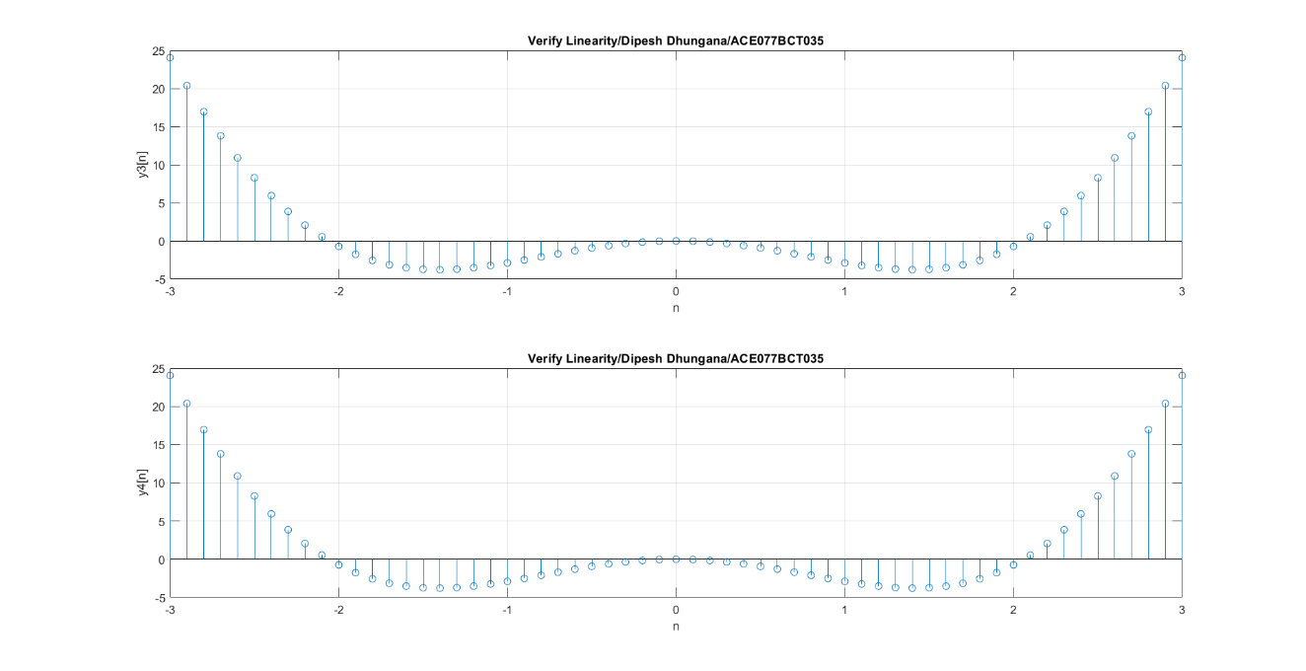

**Conclusion:**

The signal is nonlinear.

**Solution (b) (Source code)**

clc;

clear all;

close all;

a1=3;

a2=-7;

n=-3:0.1:3;

x1 = n;

x2 = sin(n);

y1 = n.*x1;

y2 = n.*sin(n);

y3 = a1 * y1 + a2 * y2;

x3 = a1 * x1 + a2 * x2;

y4 = n.*x3;

subplot(2,1,1);

stem(n,y3);

xlabel("n");

ylabel("y3[n]");

title("Verify Linearity/Dipesh Dhungana/ACE077BCT035");

grid on;

subplot(2,1,2);

stem(n,y4);

xlabel("n");

ylabel("y4[n]");

title("Verify Linearity/Dipesh Dhungana/ACE077BCT035");

grid on;

**Output (b) y[n]=x[n^2]**

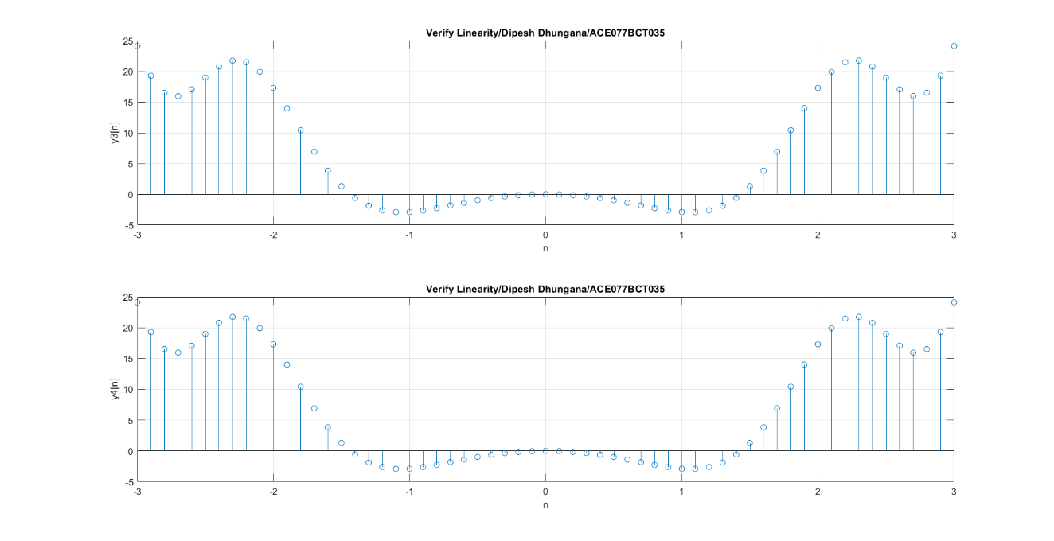

**Conclusion:**

The signal is linear.

**Solution (c) (Source code)**

clc;

clear all;

close all;

a1=3;

a2=-7;

n=-3:0.1:3;

x1 = n;

x2 = sin(n);

y1 = n.*x1;

y2 = n.*sin(n);

y3 = a1 * y1 + a2 * y2;

x3 = a1 * x1 + a2 * x2;

y4 = n.*x3;

subplot(2,1,1);

stem(n,y3);

xlabel("n");

ylabel("y3[n]");

title("Verify Linearity/Dipesh Dhungana/ACE077BCT035");

grid on;

subplot(2,1,2);

stem(n,y4);

xlabel("n");

ylabel("y4[n]");

title("Verify Linearity/Dipesh Dhungana/ACE077BCT035");

grid on;

**Output (c) y[n]=nx[n]**



**Conclusion:**

The signal is linear.

**Q2. Two discrete signals are given as h[n]={1,2,1,-1} and x[n]={1,2,3,1}.Plot these signals using convolution function.**

**Solution (Source code)**

clc;

close all;

clear all;

h = [1 2 1 -1];

nh = [-1 0 1 2];

x = [1 2 3 1];

nx = [0 1 2 3];

y=conv(x,h);

n = min(nh) + min(nx) : max(nh) + max(nx);

stem(n,y);

xlabel('n');

ylabel('y[n]');

title('With Convolution/Dipesh Dhungana/ACE077BCT035');

grid on;

**Output**

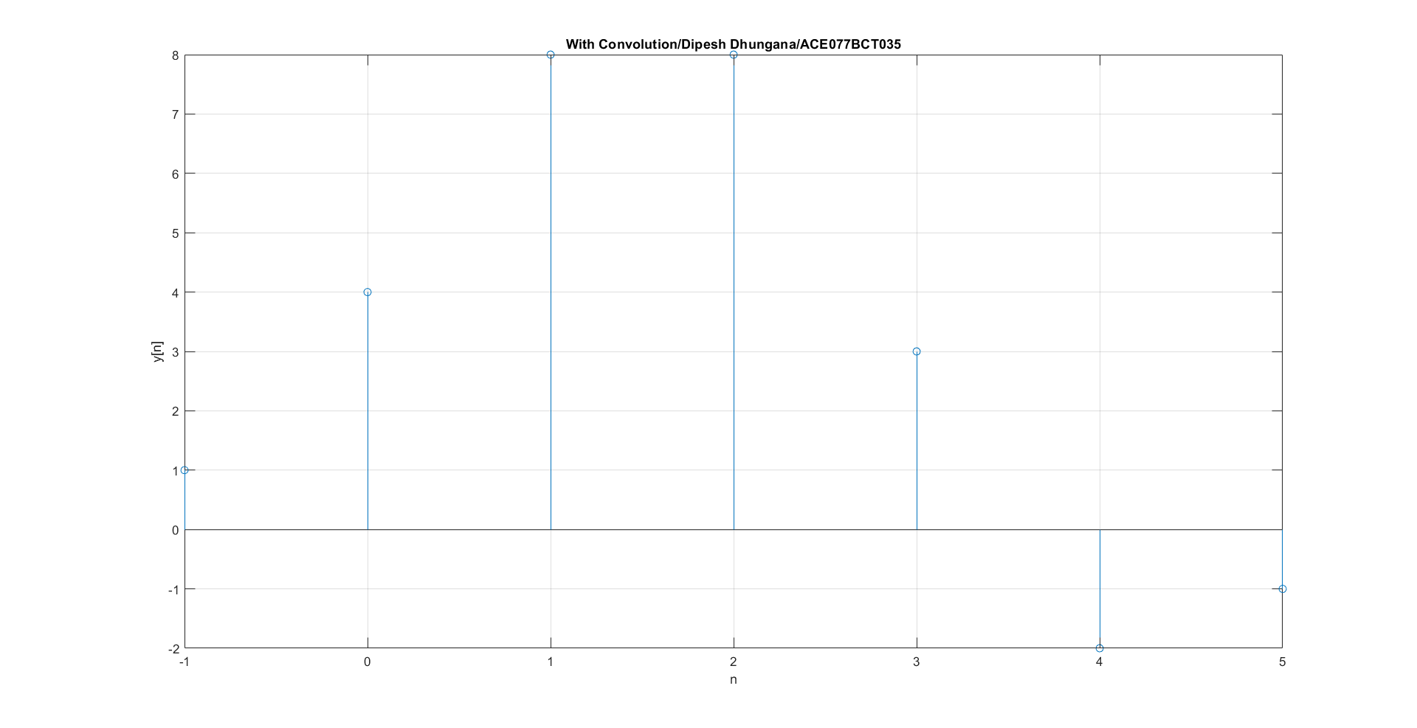

**Q3. Find zeros , poles and gain of given transfer function using tf2zp() function for G(s)= (7s+5)/(s^2+4s+3).**

**Solution (Source code)**

clc;

close all;

clear all;

num = [7 5];

den = [1 4 3];

[z,p,k] = tf2zp(num,den);

sys = tf(num,den);

pzmap(sys);

pzmap(p,z);

grid on;

sgrid;

**Output**

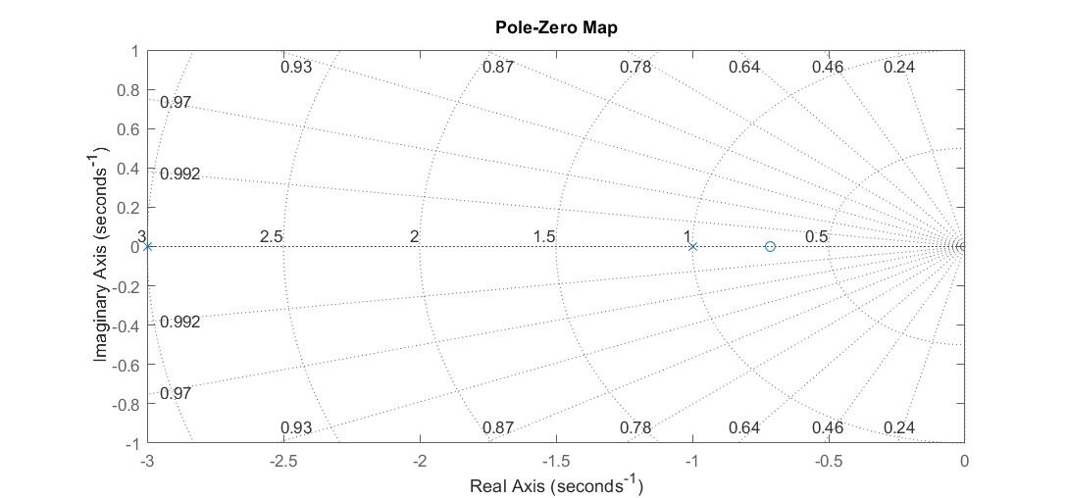

**Q4. Plot auto correlation sequence of sine wave with frequency 1HZ ,sampling frequency is 200HZ.**

**Solution (Source code)**

clc;

close all;

clear all;

A = 1;

f = 1;

fs = 200;

w = 2 * pi * (f / fs);

t = 0 : 0.001 : 1024;

x = A* sin(w*t);

subplot(2,1,1);

plot(t,x);

xlabel('t');

ylabel('x(t)');

title('Sine /Dipesh Dhungana/ACE077BCT035');

grid on;

y = xcorr(x);

subplot(2,1,2);

plot(y);

xlabel('t');

ylabel('y(t)');

title('Auto Correlation/Dipesh Dhungana/ACE077BCT035');

grid on;

**Output**

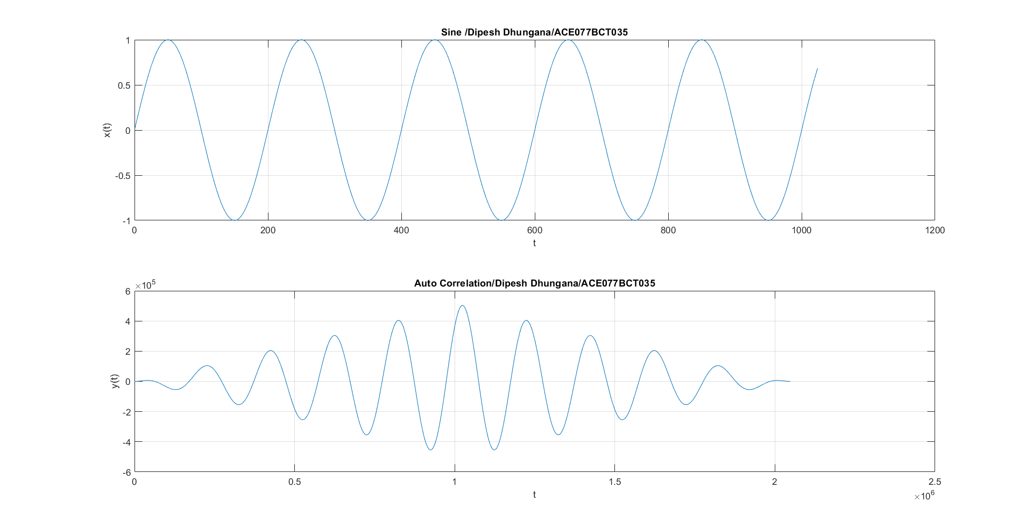

**DISCUSSION AND CONCLUSION**:

The experiments successfully demonstrated fundamental concepts in digital signal analysis and processing. The tests for linearity on three systems using given signals showed that while y[n]=x2[n]y[n] = x^2[n]y[n]=x2[n] is nonlinear, y[n]=x[n2]y[n] = x[n^2]y[n]=x[n2] and y[n]=nx[n]y[n] = nx[n]y[n]=nx[n] are linear. The convolution operation between h[n]={1,2,1,−1}h[n] = \{1, 2, 1, -1\}h[n]={1,2,1,−1} and x[n]={1,2,3,1}x[n] = \{1, 2, 3, 1\}x[n]={1,2,3,1} illustrated how two discrete signals can combine to form a new signal, highlighting the convolution function's role in signal processing. The transfer function analysis for G(s) provided insights into the system's characteristics through the pole-zero plot, while the autocorrelation of a sine wave demonstrated the signal's coherence over time.

In conclusion, these experiments underscored the importance of understanding system properties such as linearity, convolution, transfer functions, and autocorrelation in digital signal processing. These concepts are essential for analyzing and designing systems in various engineering applications, providing a solid foundation for further exploration and practical implementation in the field.